LAB 1
Spring 2012, BESE 16
Fundamental Concepts
Objective
The aim of this introductory lab is to introduce students to the concept of software design and architecture and the tools used to model these. A basic introduction to MS Visio would be given which would include the installation and usage help. The lab will also cover an introduction to UML.

Submission Requirements
You are expected to complete the assigned tasks within the lab session and show them to the lab engineer/instructor. Some of these tasks are for practice purposes only while others (marked as ‘Exercise’ or ‘Question’) have to be answered in the form of a lab report that you need to prepare. Following guidelines will be helpful to you in carrying out the tasks and preparing the lab report.

Guidelines
- Name your reports using the following convention:
  - Lab#_Rank_YourFullName
  - ‘#’ replaces the lab number
  - ‘Rank’ replaces Maj/Capt/TC/NC/PC
  - ‘YourFullName’ replaces your complete name.

- You need to submit the report even if you have demonstrated the exercises to the lab engineer/instructor or shown them the lab report during the lab session.

Tasks for Today

How to Install MS Visio:

Software Available at:
\\csdept\data\Resources\Software\Applications\Document Explorers\Office\MS Office 2007 (DVD)

Step 1: Run the setup.exe file.
Step 2: Select Microsoft Office Visio Professional 2007 and click Continue Button.
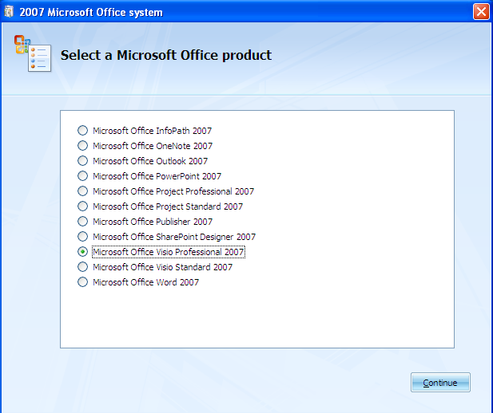
Step 3: Enter Product Key and click Continue Button. The Product key is given in text file named as Serial_No.
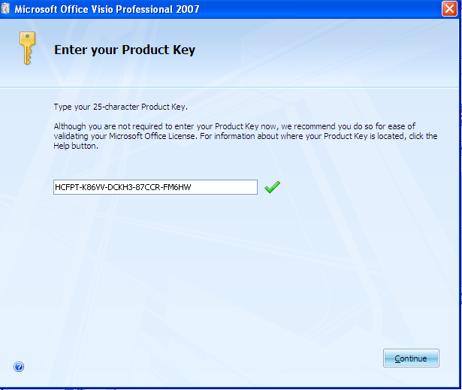

Step 4: Check the checkbox “I accept the terms of this agreement” and click Continue Button.
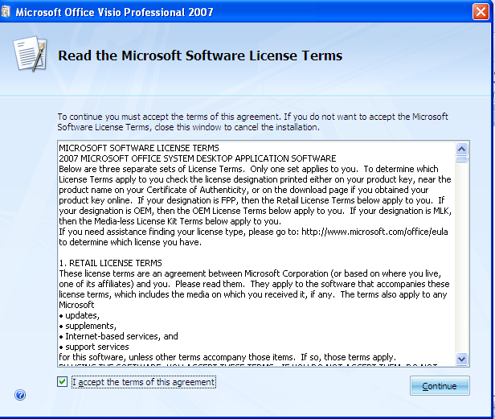

Step 5: Click Install Now Button.
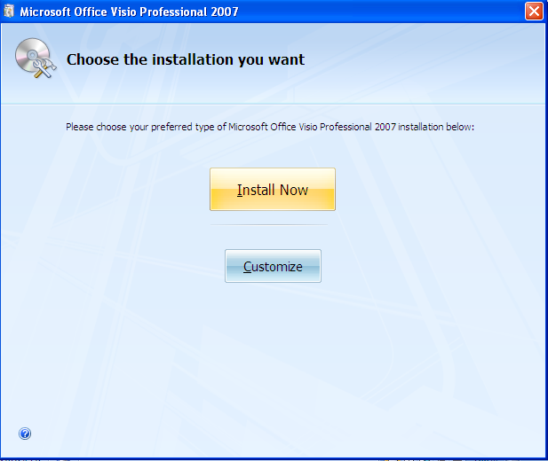

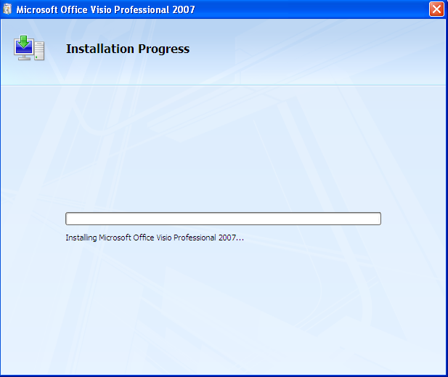

Step 6: Click Close Button.
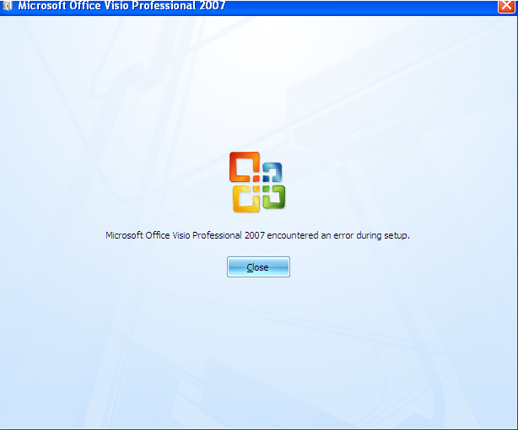

Step 7: Now Open Microsoft Office Visio 2007.
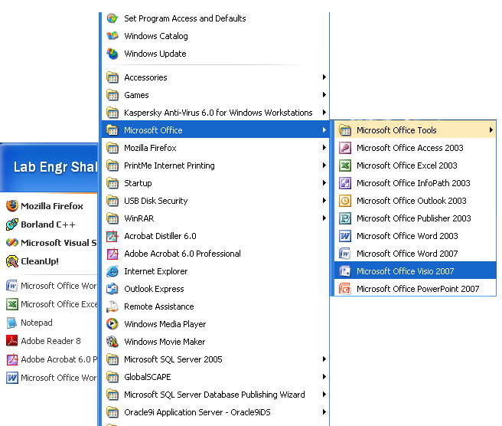

How to create your first diagram:

Step 1: Choose and open a template
1. Start Visio 2007.
2. In the Template Categories list, click Flowchart.
3. In the Flowchart window, under Featured Templates, double-click Basic Flowchart.
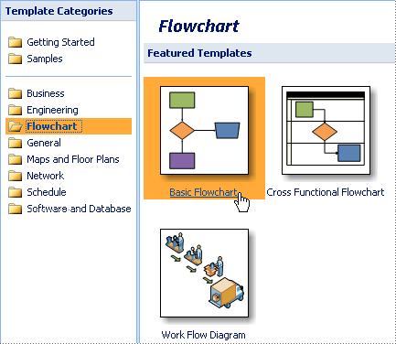

OR
1. On the File menu, point to Shapes, point to the category that you want, and then click the name of the stencil that you want to use.

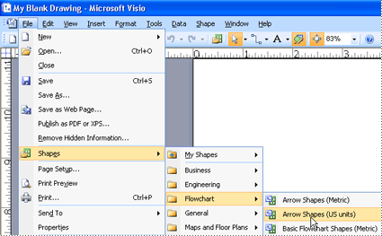

When you open a template, the shapes you need open with it, in collections called stencils. The stencils that open with the Basic Flowchart template are called Arrow Shapes, Backgrounds, and Basic Flowchart Shapes.
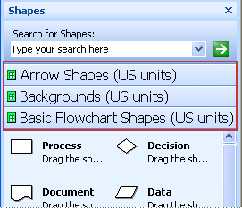

Step 2: Drag and connect shapes
To create your drawing, all you need to do is drag shapes from stencils onto the blank drawing page and connect them by dragging the shapes on top of each other.
- Drag your first shape from the Basic Flowchart Shapes stencil onto the drawing page, and then release the mouse button.
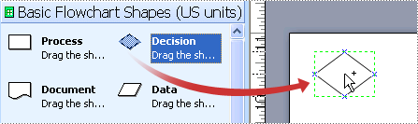
- Drag your second shape on top of the first so that the blue arrows show, but don't release the mouse button yet.
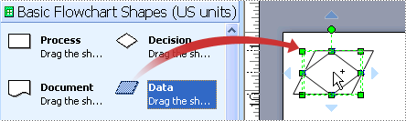
- While holding the mouse button, move your pointer on top of the blue arrow that points toward where you want to place the second shape.
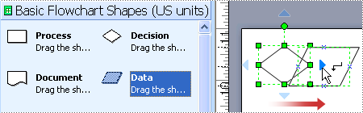
- Now release the mouse button. Your shapes are connected, and the first shape points to the second shape.
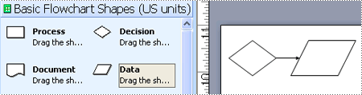
- Continue to build your drawing by repeating steps 2-4.

Step 3: Add text to shapes

Add text directly to a shape
- Double-click the shape.
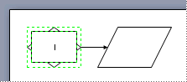
- Start typing.
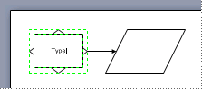
- When you finish typing, click on a blank area of the drawing page.
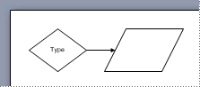
Also see visio quick reference pdf file given along with the manual.

TASK 2:
Flow chart is a fundamental design diagram. The symbols used in flowcharts are given in the document provided with this manual.

Design a flow chart for given algorithm:

Question 1:
Finding an Armstrong number:
An Armstrong number of three digits is an integer such that the sum of the cubes of its digits is equal to the number itself. For example, 371 is an Armstrong number since 3**3 + 7**3 + 1**3 = 371.

Algorithm:
- Start the program (Connector Symbol- Oval Shape)
- Get the input (a number) from the user (n) - (Input/Output Symbol-parallelogram)
- Store the number in an int variable (m=n)
- Initialize the sum as Zero (sum=0)-(Rectangle)
- check the decision as while(n>0)-(Diamond Shape)conditional (or decision), represented as a diamond (rhombus)
- If this yields true then process as follows:(Processing Symbols-Rectangles)
(remainder) r=n%10;
sum=sum+(r*r*r);
n=n/10;
- Check the decision statement again and continue with the process until the condition becomes false.
- Finally check m with sum
- If the sum==m Then print the number is an Armstrong-(Output Symbol-parallelogram)
- Else not an Armstrong
- Terminate the Program.(Oval shape)

Question 2:
Draw and submit flowchart for a cashier program. The program works as follows:
  - First it asks user to enter the code of the item purchased by a customer.
  - If item code is valid, the description and price for that code is displayed on the screen.
  - If item code is invalid, message is displayed “Item Code doesn’t exists”.
  - Then it asks for the quantity of the particular item code entered. If quantity is less than zero, it prompts user to enter quantity greater than zero.
  - It displays the subtotal thereafter.
  - Moreover, it keeps on accepting item codes until ‘0’ is pressed.
  - Consequently, it displays the total amount due.
  - Then, it asks the user to tender the amount of cash of the customer. It should not accept amount of cash less than the amount due.
  - Finally, it displays the change.

TASK 3:
Submit a Software Requirement Specification document of any system by next lab. [Individual Submissions]

